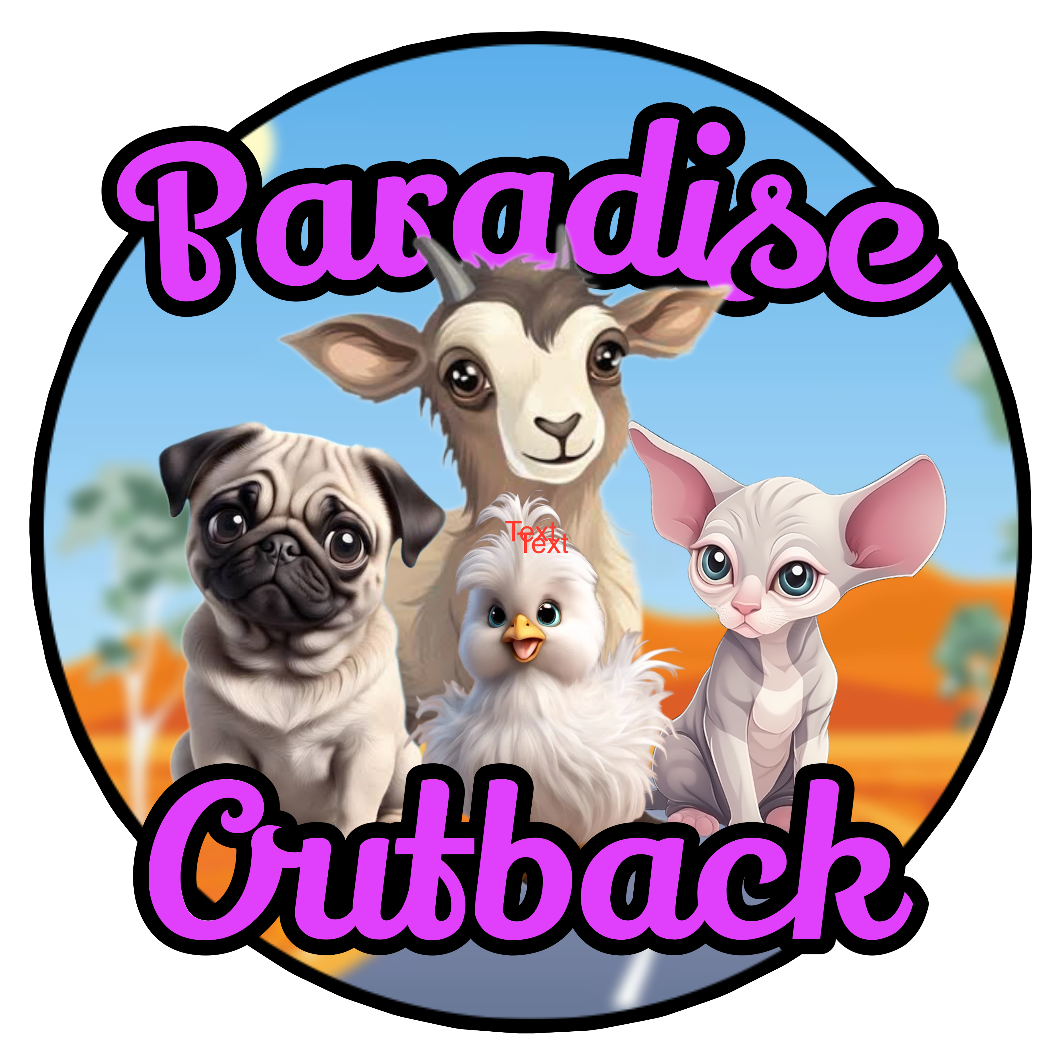

0487 000 708

Susan & Wayne

Congratulations!!!

On adopting one of Paradise Sphynx kittens

We wish you, and your family many years of fun, love and happiness.

This little booklet we hope will help with settling your new baby into their furever home.

YOUR KITTEN WILL BE

Vaccinated

Vet checked

Wormed

Socialised with cats, dogs, kids and adults

Microchipped and loved

We do recommend visiting your vet within the first few days for your own peace of mind.

**1. Vaccination:** Your kitten will have had 1st vaccine and 2nd one will be on due date which is written on vet paperwork and then a 3rd one 4 weeks after and thereafter every 12 months.

**2. Vet Checked:** Your kitten has been thoroughly checked over by our vet and is in good health when he/she leaves here.

**3. Worming**: Your kitten has be wormed at 2, 4 and 8 weeks of age and is due to be done again at 12 wks and then every three months. We recommended Milbemax worming tablets

**4. Socialised**: Your kitten has been very well socialised since birth with daily handling and everyday noises surrounded by other dogs and cats. The crucial time of socialising and bonding is between the age of 7 – 14 weeks when this will help form your kittens personality.

**5. Micro-Chipped**: Your kitten has been micro-chipped and you will receive this paper work with you Kitten with the information to change over to your name and register with your local council.

**Flea Treatment**

All our cats at Paradise Outback Animals are treated with Nexgard monthly for fleas and ticks.

**Grooming**

Choose gentle cat shampoos that are soap free and made with natural ingredients like oatmeal, aloe or coconut oil. When finished bathing make sure you dry your baby completely to keep them warm. Because they have little to no hair in their ears wax accumulates in their ears and needs to be cleaned out with an ear cleaner you can buy from the pet store and cotton tips.

**Introducing other animals**

I would go slow keep them apart for a couple a days and let them see each other through a door make sure you are praising the original animal for good behaviour Treats can work too.

**Food**

Your Kitten has been eating royal canin kitten dry food, sometimes kitten wet food from supermarket and kangaroo meat.

**General**

The Sphynx cat is a very affectionate,

Curious, energetic, cuddly and extroverted. They are very social and do not like being alone Its recommended you have two if you are away from home a lot. If you have a small dog they will buddy up with them.

He /she will simply steal your heart .

If within 3 days you no longer want your dog I will take him/her back and refund 50% of purchase price.



Susan & Wayne

Paradise Outback Animals

You can find us on facebook please like us and leave a review if you were happy with your pup and service

0487 000 708

https//:paradiseoutbackanimals.com.au

