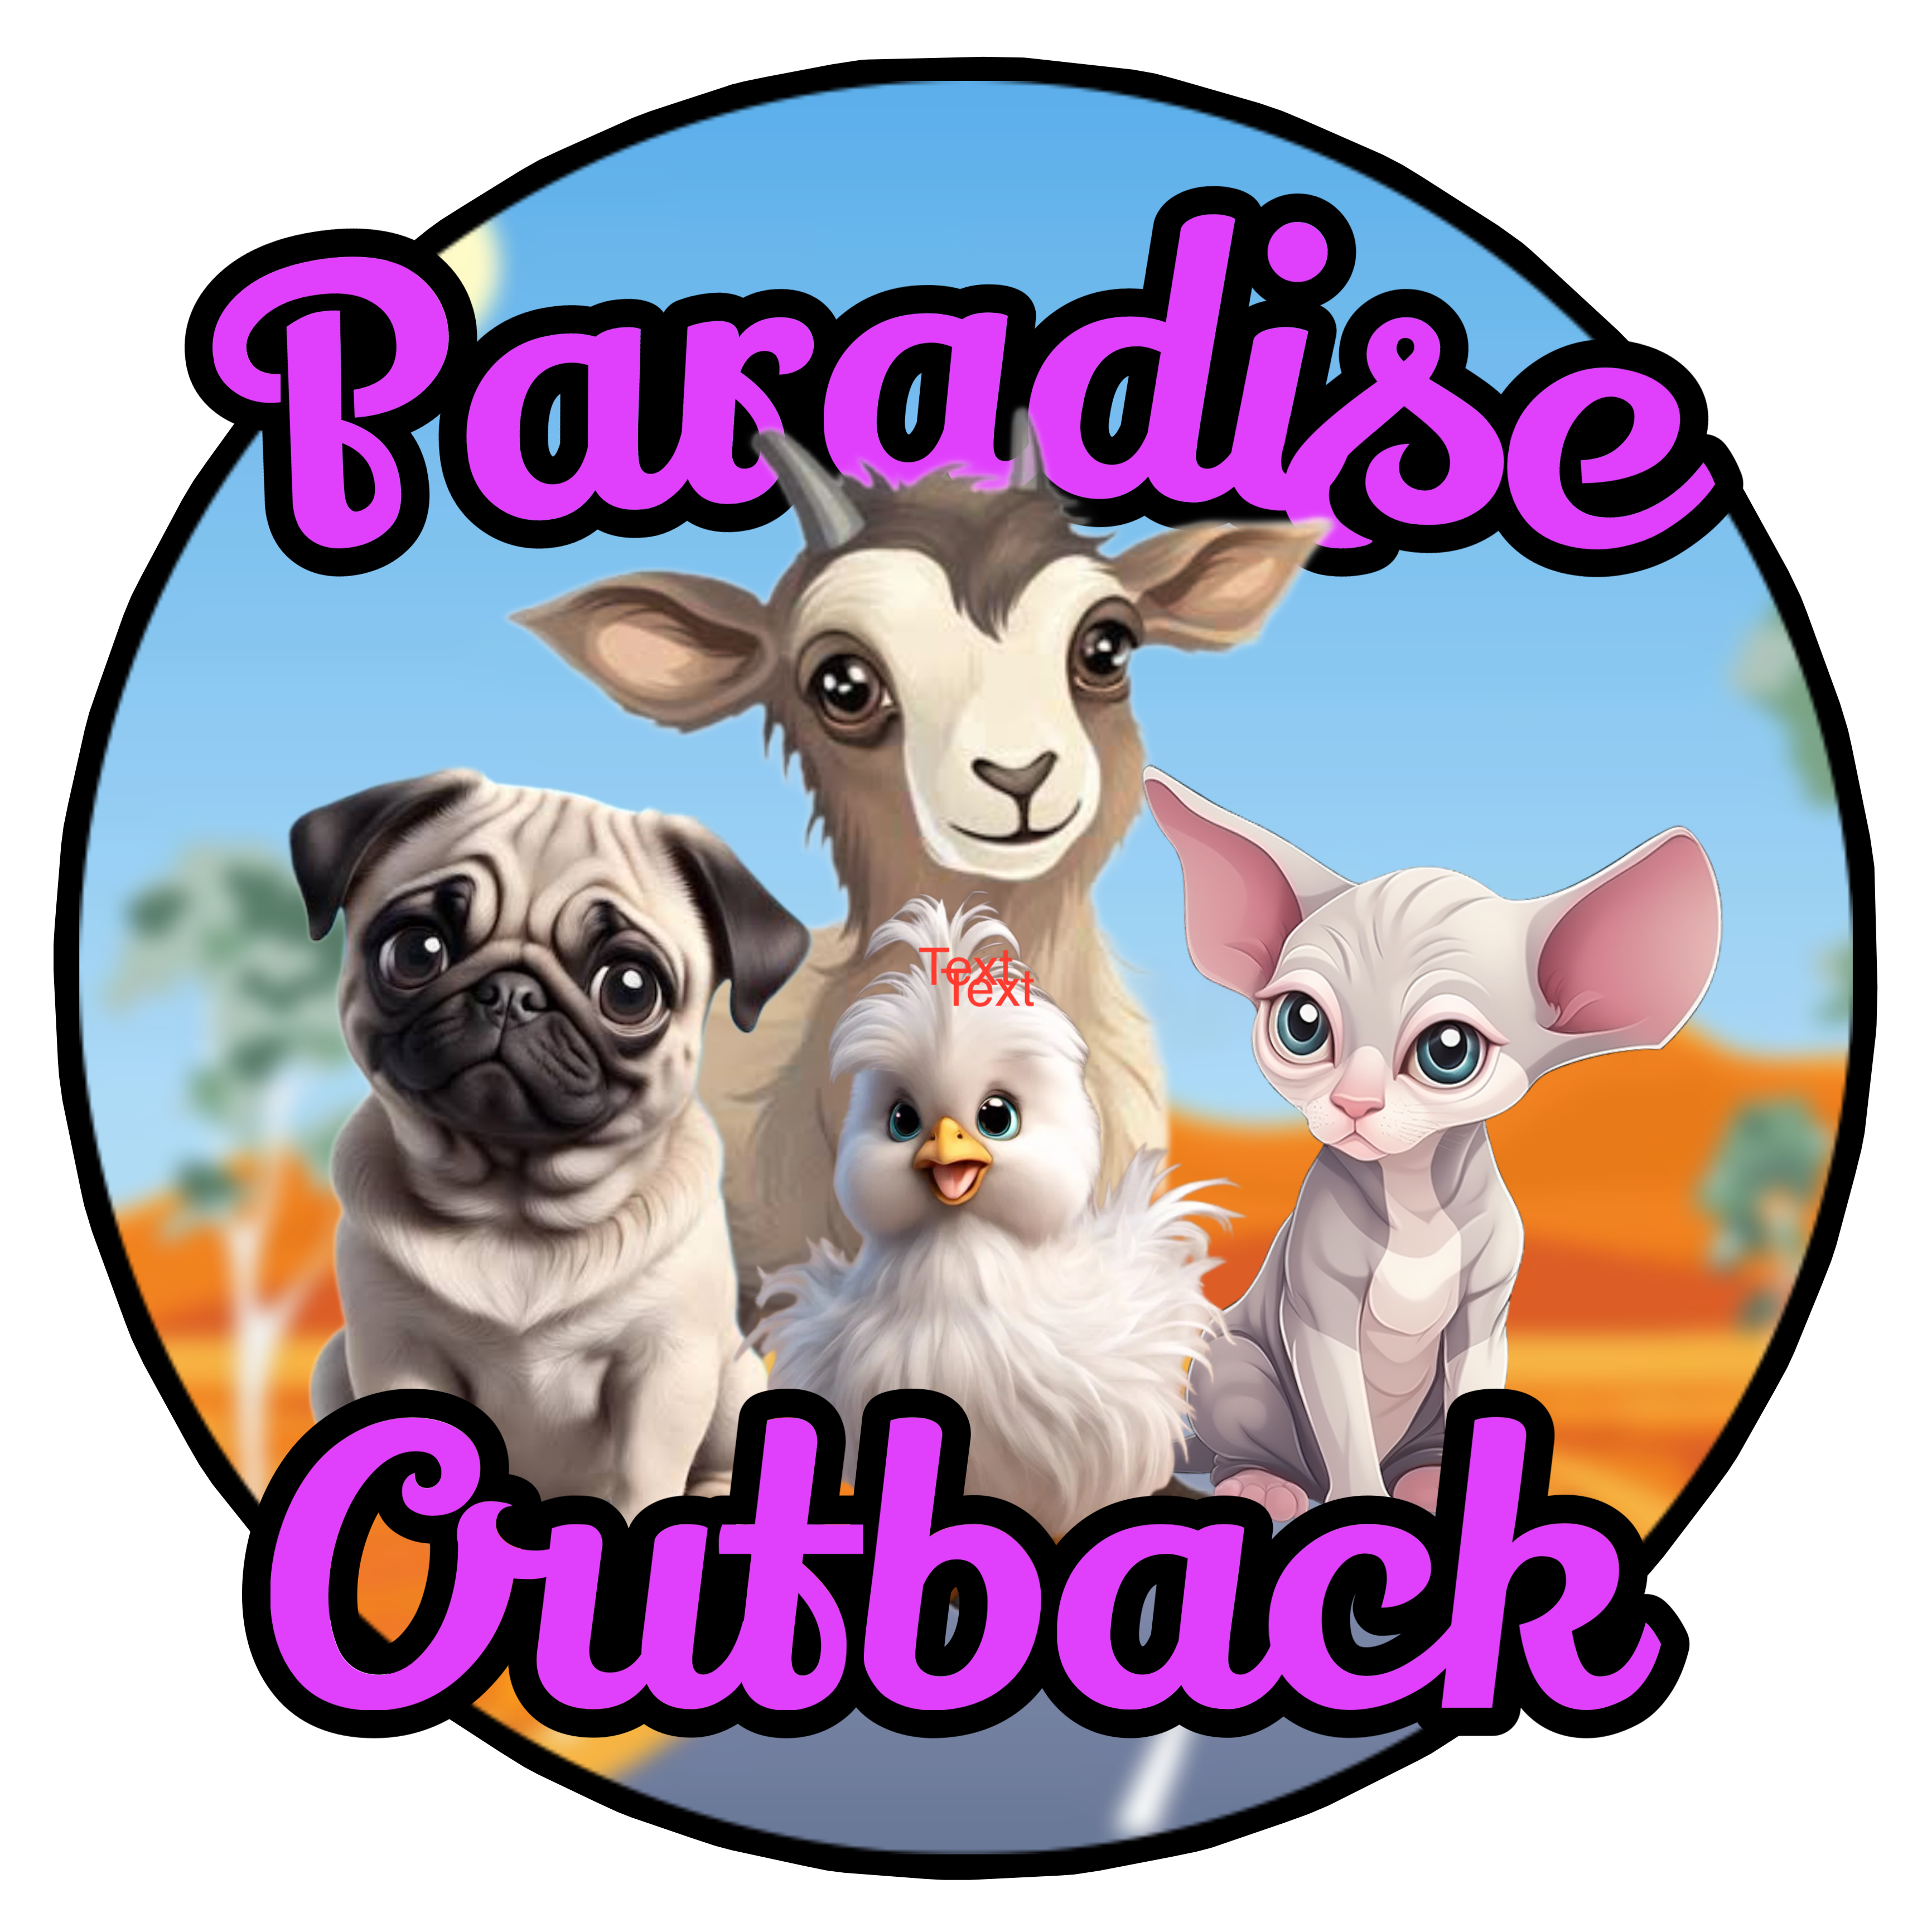

0487 000 708

Susan & Wayne

Congratulations!!!

On adopting one of Paradise Poodle/Cavoodle Puppies.

We wish you, and your family many years of fun, love and happiness.

This little booklet we hope will help with settling your new baby into their furever home.

YOUR PUPPY WILL BE

Vaccinated

Vet checked

Wormed

Socialised with cats, dogs, kids and adults

Microchipped and loved

We do recommend visiting your vet within the first few days for your own peace of mind.

**1. Vaccination:** Your pup will have had 1st vaccine and 2nd one will be on due date which is written on vet paperwork and then a 3rd one 4 weeks after and thereafter every 12 months.

**2. Vet Checked:** Your pup has been thoroughly checked over by our vet and is in good health when he/she leaves here.

**3. Worming**: Your pup has be wormed at 2, 4 and 8 weeks of age and is due to be done again at 12 wks and then every three months. We recommended Milbemax worming tablets We also strongly recommend talking to your vet about heartworm protection asap.

**4. Socialised**: Your pup has been very well socialised since birth with daily handling and everyday noises surrounded by other dogs and cats. The crucial time of socialising and bonding is between the age of 7 – 14 weeks when this will help form your puppies personality.

**5. Micro-Chipped**: Your pup has been micro-chipped and you will receive this paper work with you pup with the information to change over to your name and register with your local council.

**Flea Treatment**

All our dogs at Paradise Outback Animals are treated with Nexgard monthly for fleas and ticks.

**Grooming**

Poodle require a quick brush regularly to keep knots at bay. Also I would recommend finding a groomer for your baby as he or she will need a regular visit Nails needs a quick little trim every two weeks generally. We love using a pet nail grinder its quick and easy.

**Introducing a new Puppy!**

We think the best way to introduce a new pup is to firstly understand she/he has been raised and spoilt by us, so will be a bit worried about you and the new surroundings. So start small, its best if you can have one room or area that puppy can have as safe zone. Bonding in the early days is very important for you both too. Its best for you both if when you pick your puppy up you can have a couple of days at home with him/her to settle in and get them used to their new surroundings. Give your baby lots of cuddles and love

Feed pup in the same area all the time so he/she isn’t confused always leave water and dry food down for grazing. The hardest time for your puppy will be at night, when suddenly alone, without any brothers or sisters to snuggle up too. The first few nights a well-wrapped hot water bottle in its bed is a great replacement. It will need a bed of its own with a piece of soft warm blanket. Decide now whether your puppy is going to be allowed to sleep on the bed, in the bedroom, in the laundry. It can be very confusing and distressing for a puppy to sleep on the bed for a week then on the floor, make sure whatever area you decide on its warm. Do not get up to your puppy every time he/she cries. By doing so, you are rewarding the crying behaviour and they will learn very quickly that if they cry you come running to give them a cuddle. Have a good play session last thing at night then off to bed. Between 6 and 14 weeks of age is the most rapid learning time for your puppy. Early puppy hood experiences can play a major role in the pup’s adult life. One of the first things you need to start teaching your puppy is good toileting behaviours.

**What to feed your Pup**

Pup has been eating Royal Canin puppy biscuits. I also feed Prime 100 puppy rolls that can be bought a pet shops . We are also giving the pups brisket bones and carrot sticks which is great from dental hygiene.

During the settling in period you may find your puppy not eating as much as he/she should. The spirit of competition amongst litter, at feeding time no longer exists. The best idea is to leave the food down for about 10 minutes, after this, what has not been eaten, take it away and try not to give it tit-bits between meals. Try to stick to regular meal times and you will soon learn to judge how much the puppy needs.

They can also have the following

Vegetables:

Pumpkin

Peas

Carrots

Broccoli

Cauliflower etc.

Must be mashed or puree.

Fruit:

Apples

Bananas

Pears

Must be chopped up into small pieces.

TRAINING YOUR PUPPY

It is very important that you start training your puppy from an early age. Many people let their puppy run wild until they are 5 or 6 months old and the try to undo all the bad or undesirable habits their puppy has learned.

Puppies can be started on basic training from as early as eight weeks of age. They will quickly learn basic commands like coming when called, sit and drop on command and stay. It is very simple to teach your puppy to do these few simple things using food as a reward. Socialisation is essential from an early age meaning different people, animals and situations.

**General**

Poodles are a very loyal social breed and therefore require a lot of human attention.

They needs lots of toys that need rotating to avoid boredom.

Poodles are a very smart breed and you can teach them a lot of tricks

A young puppy does not need to be taken for a walk and should not be until last vaccine has been given under instruction from vet.

He she will get sufficient exercise running around the garden and playing with the family. Puppies need lots of sleep, so if you have young children make sure the puppy gets time away from them. Sleep is vital to enable it to grow properly.

TOILET TRAINING

As soon as you get your puppy home, take him/her to the area that you would like used as a toilet. Your puppy has a very little bladder control and will need to be taken to this spot every 2 to 3 hours throughout the day and night, as soon as he/she wakes up from a sleep and after every meal or drink. As soon as the job is done reward puppy with a pat or piece of food. If nothing happens go back 5 minutes later and try again.

It is not as good idea to put paper down at night for them to go to the toilet on. This only starts teaching them to go inside. If your puppy has an accident in the house, rubbing noses and scolding is not the way to go. Simply clean it up with warm water followed by a rinse with a solution of warm water and vinegar or sudsy ammonia. This will kill the odour and prevent discolouration. It should only take a few days for puppy to get the idea in his mind, and then you can let puppy roam the house. BUT!! Keep an eye on him/her. If you have any questions regarding your new baby please feel free to call me and I will try to help you.

If within 3 days you no longer want your dog I will take him/her back and refund 50% of purchase price.



Susan & Wayne

Paradise Outback Animals

You can find us on facebook please like us and leave a review if you were happy with your pup and service

0487 000 708

https//:paradiseoutbackanimals.com.au

